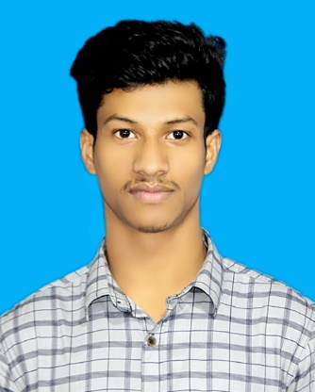***RESUME***

*of*

***Md. Mizanur Rahman***

***Mailing Address:***

*Block-D, Road-02, House-13*

*Mirpur-12, Dhaka -1216*

*Cell: 01763393113*

*E-mail: mizanahmed5316@gmail.com*

***Career Objective***

*To pursue a work by which I can serve by using my vision, positive attitude, interpersonal relationship, communication skill to take the challenges that will also ensure me the opportunity to grow by learning new skills and knowledge as well as develop your organization.*

***Academic Certification***

***Bachelor of Arts (Degree)***

*Institution Name : National University*

*Graduation : BA*

*Session :2019-2020*

*Year : Third Year Running (Degree)*

***Higher Secondary Certificate (H.S.C)***

*Institution Name : Banglabazar Fatema Khanam College*

*Group : Business Management*

*Result : GPA- 4.58*

*Passing Year : 2019*

*Board : Technical Education Board*

***Secondary School Certificate (S.S.C)***

*Institution Name : Shahed Salam Secondary School*

*Group : Humanities*

*Result : GPA- 3.05*

*Passing Year : 2017*

*Board : Barisal*

***Training***

***Organization Name:*** *Bhola Technical Training Center (TTC)*

*Title: Computer Operation*

*Duration: 6 Months*

***Organization Name:*** *Basis SEIP program*

*Title: Front-end Development*

*Duration: 3 Months*

***Organization Name:*** *Basis SEIP program*

*Title: Graphics Design*

*Duration: 3 Months*

*Programming Skill: HTML5, CSS3, Bootstrap framework 5.0, JavaScript, jQuery, WordPress Theme Customization & Development.*

***Personal Information***

*Name :* ***Md. Mizanur Rahman***

*Father’s Name : Musa Kalimulla Dali*

*Mother’s Name : Beauty Begum*

*Permanent Address : Vill- Northy Digoldi, P.O- Northy Digoldi*

*P.S- Bhola, Dist- Barisal*

*Date of Birth : 12th May, 2001*

*Nationality : Bangladeshi (by birth)*

*Religion : Islam*

*Marital Status : Unmarried*

*Sex : Male*

*Blood Group : O+ (Positive)*

*Height : 5'4”*

***Language Proficiency***

*Bengali (Excellent Reading, Writing & Speaking)*

*English (Good Reading, Writing & Speaking)*

***Personal Strengths***

* *Industrious*
* *Excellent Communication capacity.*
* *Motivating, Leading & Convincing power.*
* *Helping mentality & realistic.*
* *Like serving people*

***Hobbies***

*Traveling, Photography, Gardening, Enjoying Movies.*

***Declarations***

*I the undersigned certify that according to my knowledge and belief, this CV correctly describes my qualification, my experience and myself. I understand that any willful misstatement here may lead to my disqualification.*

***References:***

|  |  |  |  |
| --- | --- | --- | --- |
| *1.* | ***Md. Abu Bakkar Siddique***  *NRB Commercial Bank*  *Ecorea Brunch*  *Junior Officer*  *Cell: 01711661300­­­­* | *2.* | ***Ronok Hasan***  *Senior Officer*  *IPDC Finance Ltd.*  *Gulshan, Dhaka*  *Mob: 01672454105* |

*............................................*

*Date:*  ***Md. Mizanur Rahman***